Shirley4Travel Agency
shirley4travel@yahoo.com
http://shirley4travel.com
Office 817-715-8705 Shirley Hudson, Travel Agent
Royal Caribbean-Rhapsody of the Seas 7 night Mediterranean Cruise
Sail Date: August 23, 2015 Departure Port: Rome, Italy
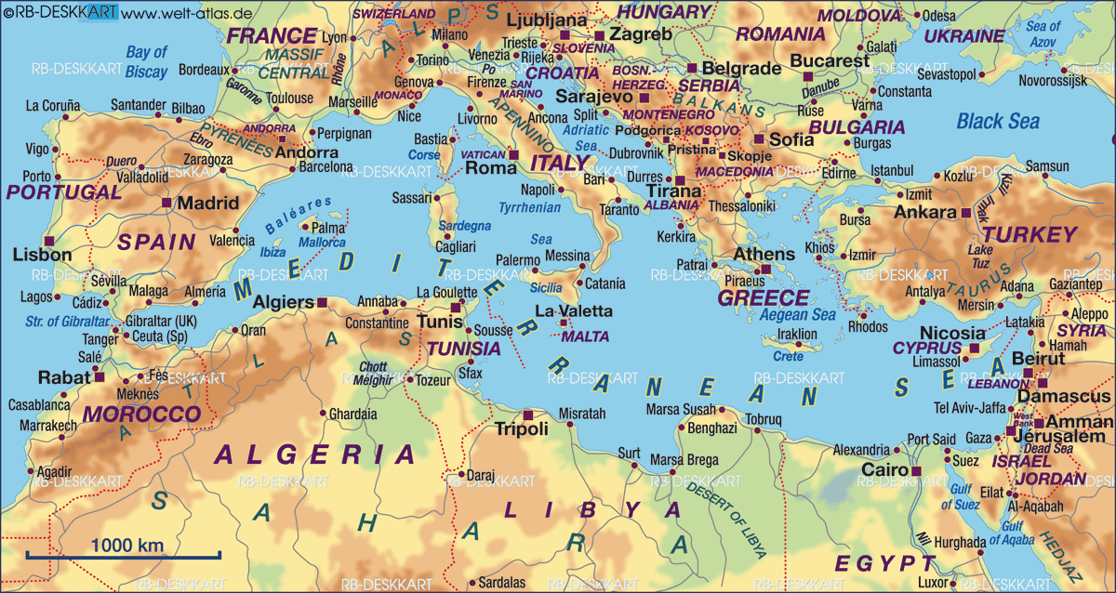

Ports of Call:
Rome (Civitavecchia), Italy Santorini, Greece
Ephesus ( Kusadasi), Turkey Bodrum, Turkey
Chania (Souda), Crete, Greece Rome (Civitavecchia), Italy

Whether you are a seasoned or first time cruiser, I welcome the opportunity to work with you. Because of the popularity of Mediterranean Cruises, choice cabins will go quickly. It is never too early to reserve your cabin. Call me for special promotional offer when you book your cabin by June 15, 2014.
You will have until June 1, 2015 to make final payment.

$2180.18 Superior Oceanview w/Balcony Category D2
$2290.18 Superior Oceanview w/Balcony Category D1
$1410.18 Large Oceanview Category H
$1200.18 Interior Category M

(Prices are per person, based on double occupancy. Air fare not included. Fares based on availability at time of booking.)

*Book early for best cabin selection
*Call for details about special early booking promotion
*$500.00 deposit per cabin based on double occupancy will hold your cabin
* Final payment due June 1, 2015

Contact Shirley4Travel Agency at 817-715-8705

