Shirley4Travel Agency
shirley4travel@yahoo.com
http://shirley4travel.com
Office 817-715-8705 Shirley Hudson, Travel Agent
DISCOVER ALASKA
May through September 2014/2015

Cruise Lines:
Princess Royal Caribbean
Disney Norwegian
Holland America Carnival
Celebrity Oceania

Departure ports:
Seattle, Vancouver, Anchorage, San Francisco

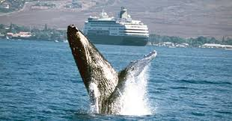

Alaskan ports of call:
(Varies according to itinerary chosen)
Juneau Victoria, BC Glacier Bay
Anchorage Ketchikan Tracy Arm Fjord
Skagway Denali Seward

Whether you are a seasoned or first time cruiser, I welcome the opportunity to work with you. Because of the popularity of Alaskan Cruises, choice cabins go quickly. It is never too early to reserve your cabin. Call for promotional offers. Call for pricing and special offers. Contact Shirley4Travel Agency at 817-715-8705

